Name: Surya Karthik
Project: Cloud Misconfiguration Detection using Supervised ML
Week 6 Deliverable
This week, I transitioned from planning the architecture design to implementing some of the proposed methods and procedures. I followed the codebase structure that I outlined in the Week 5 assignment. The primary focus was on establishing the pipeline's cybersecurity capabilities, which involved data ingestion, labeling, and feature extraction. Adding to this, I prepared the AI/ML component to get ready for model training.
The attached data ingestion code is fully functional and effectively loads AWS configuration data stored in JSON format. The code converts it from JSON to a structured tabular form using pandas. As of now, the dataset consists of staged AWS configurations from S3 buckets, IAM policies, and security groups. I chose this approach of staging data from my own account as a way of controlled testing before introducing broader real-world datasets.
Data Ingestion:
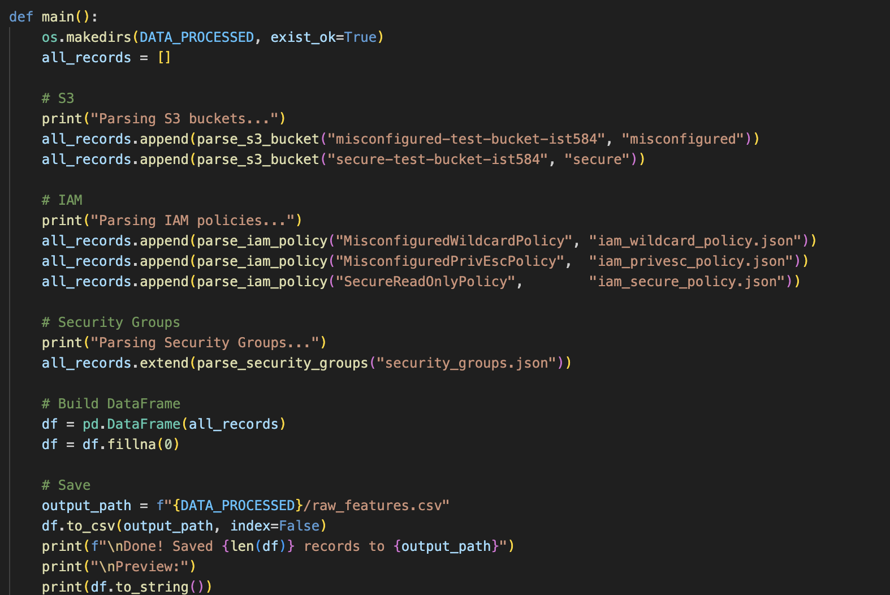

After the data has been ingested, the next step is focused on applying CIS AWS Foundations Benchmark and AWS Config Managed Rules to label each configuration record as either secure (0) or misconfigured (1). The current implementation covers S3, IAM, and Security Group, and checks against the most common misconfiguration indicators. The labelling approach that is currently implemented is consistent with the outline mentioned in Week 4.
Data Labelling:
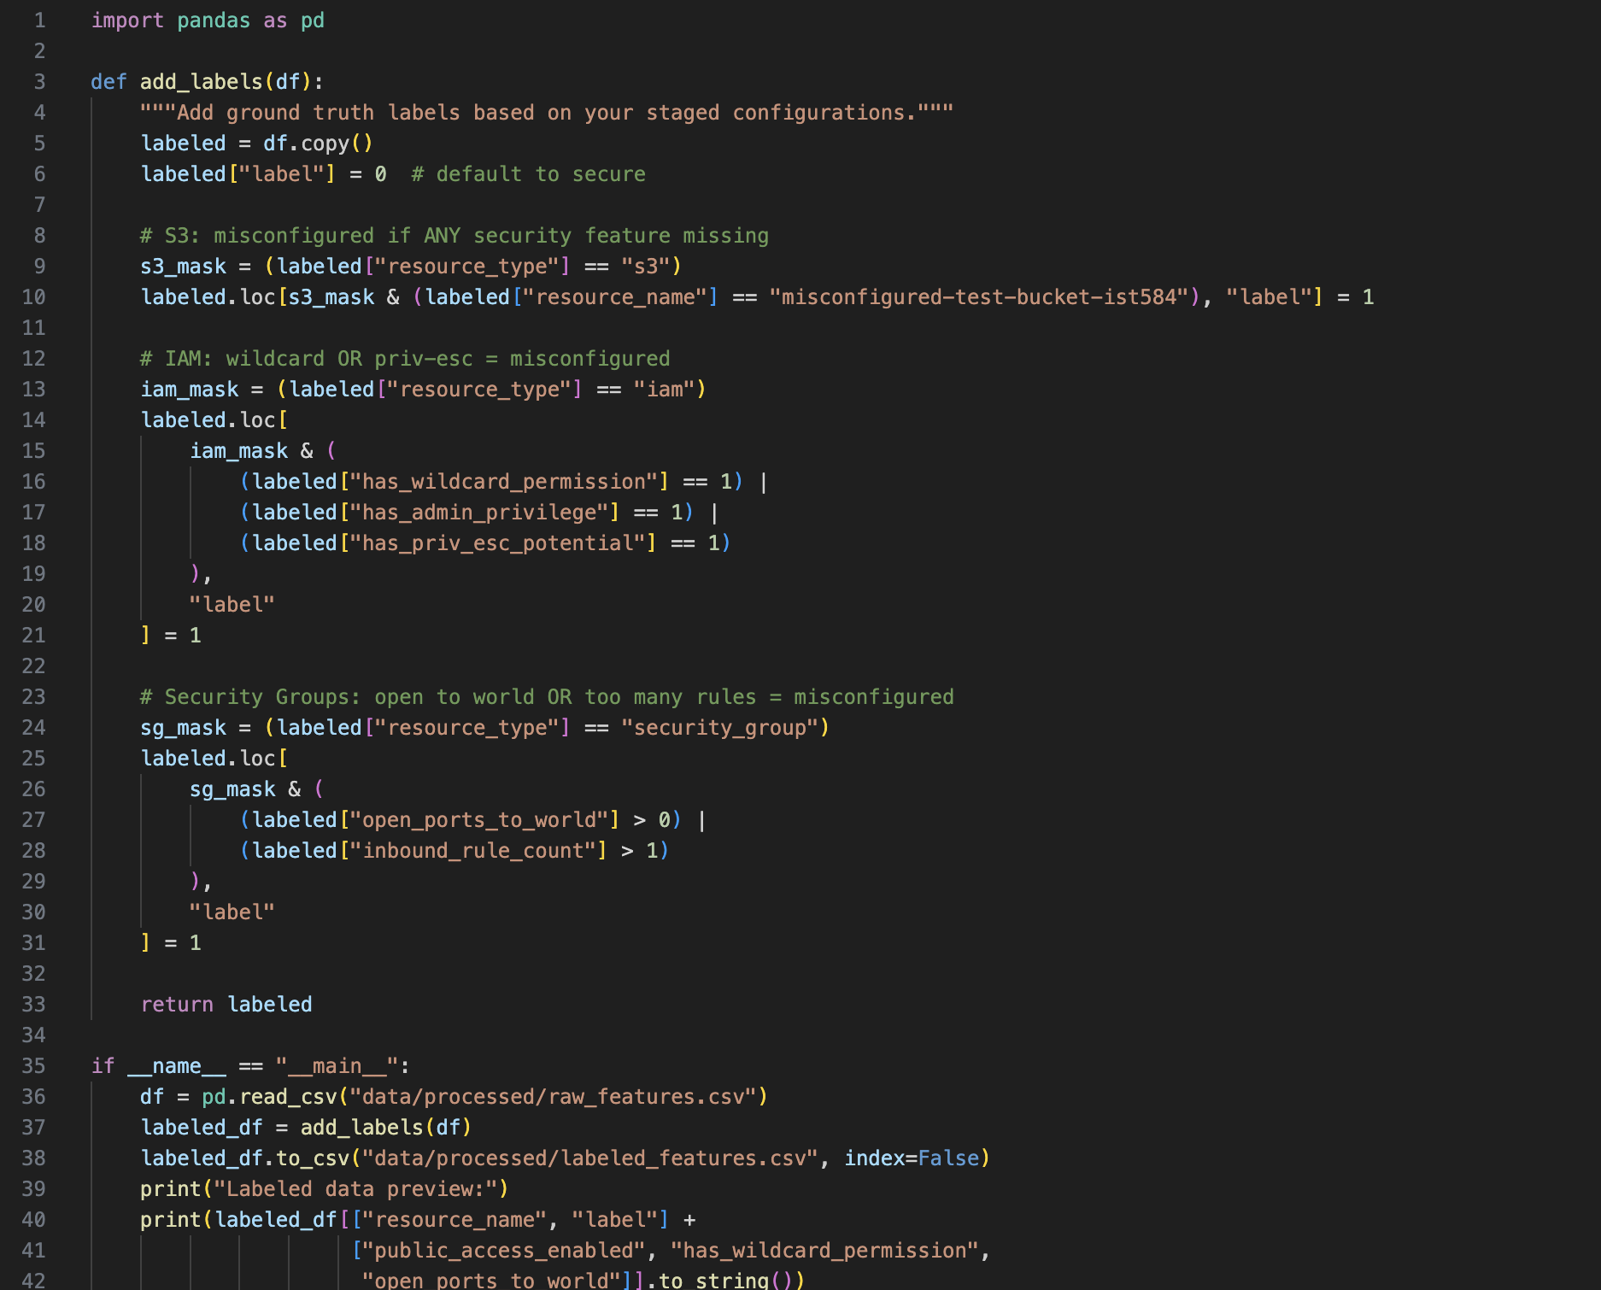
One challenge I faced during this process was labelling consistency. For example, some configuration records pulled from the staged account contained partial or missing fields, which caused the rule-based labeling functions to default to secure rather than flag it as missing.
For feature engineering, each feature is encoded as a 0 or 1 so that the raw configuration attributes can be converted into numerical values that the model can learn from. Features extracted include public access block status, encryption enabled, versioning, logging, wildcard IAM permissions, admin privileges, open ports, and inbound/outbound rule counts. This mainly covers the security-relevant properties of each resource and would eventually lead to the final product of outputting a misconfiguration risk score.
After extracting features and labels, I have started the process of developing Random Forest and Logistic Regression. An initial forward pass on the staged dataset produced preliminary risk scores, confirming the pipeline is functioning end-to-end. I plan to complete full model training with a broader dataset this week, along with the baseline rule-based implementation for comparison.
Model Training:
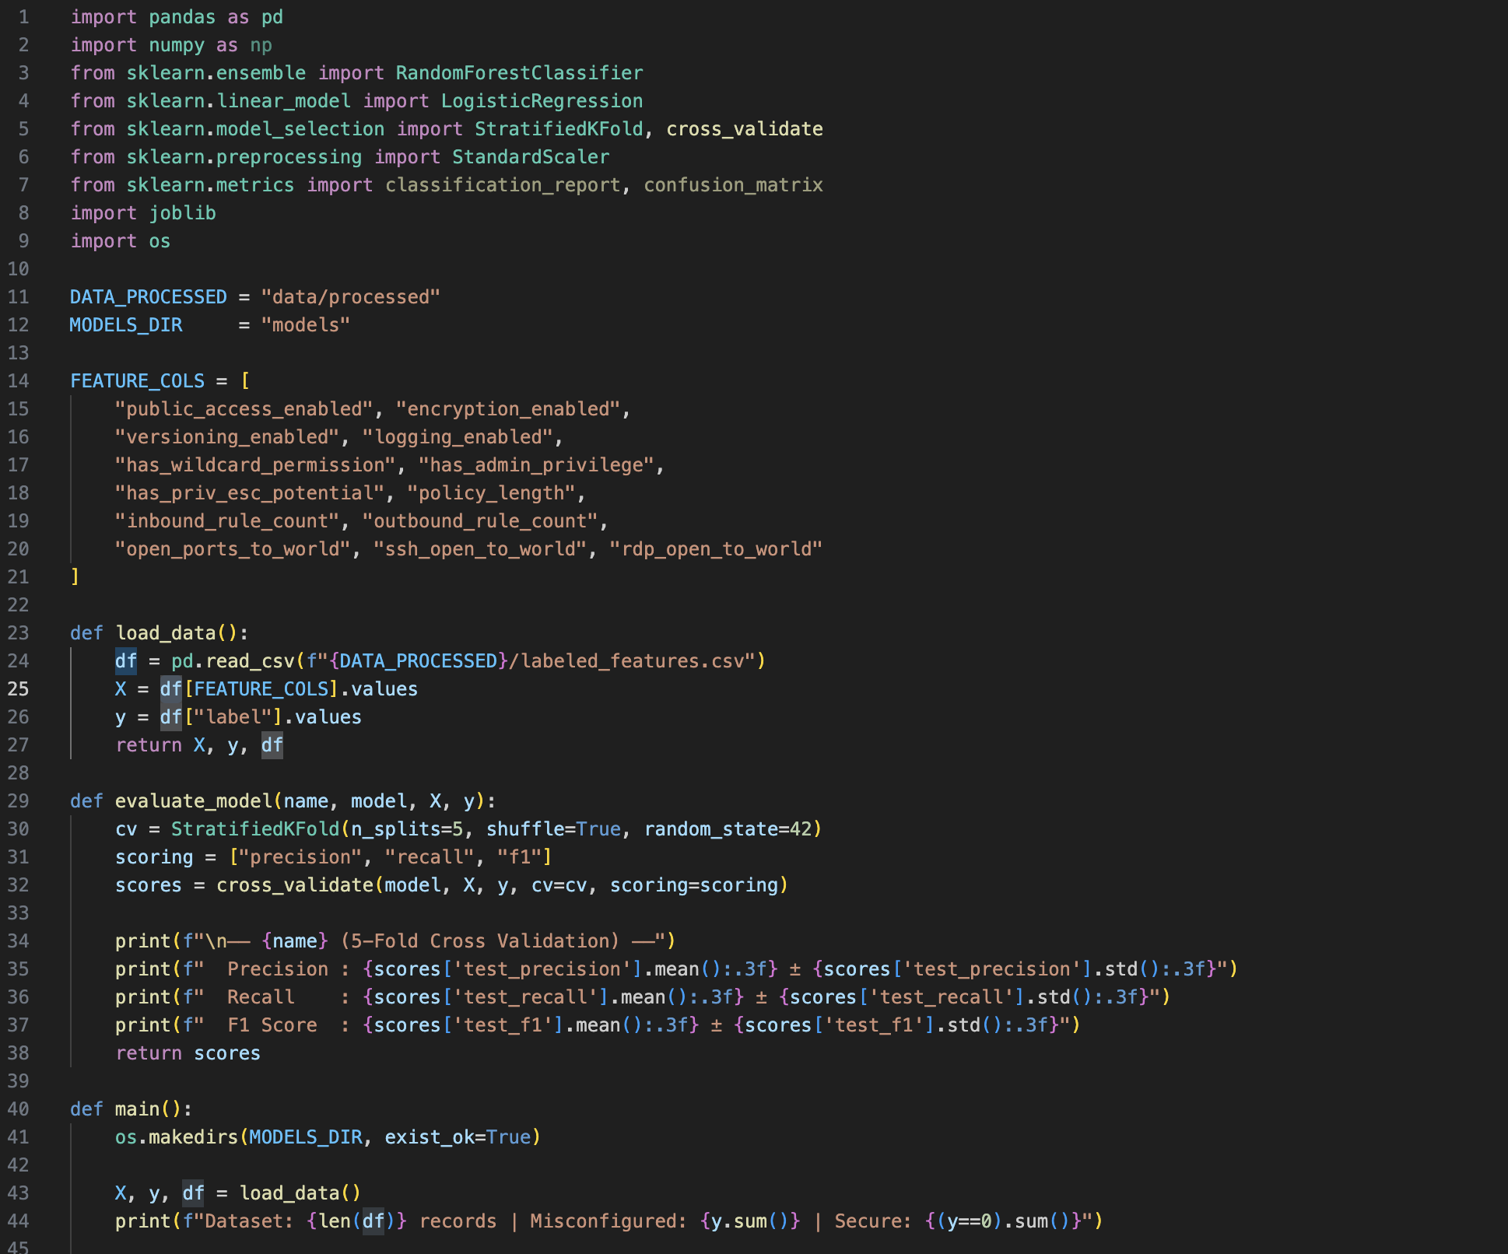
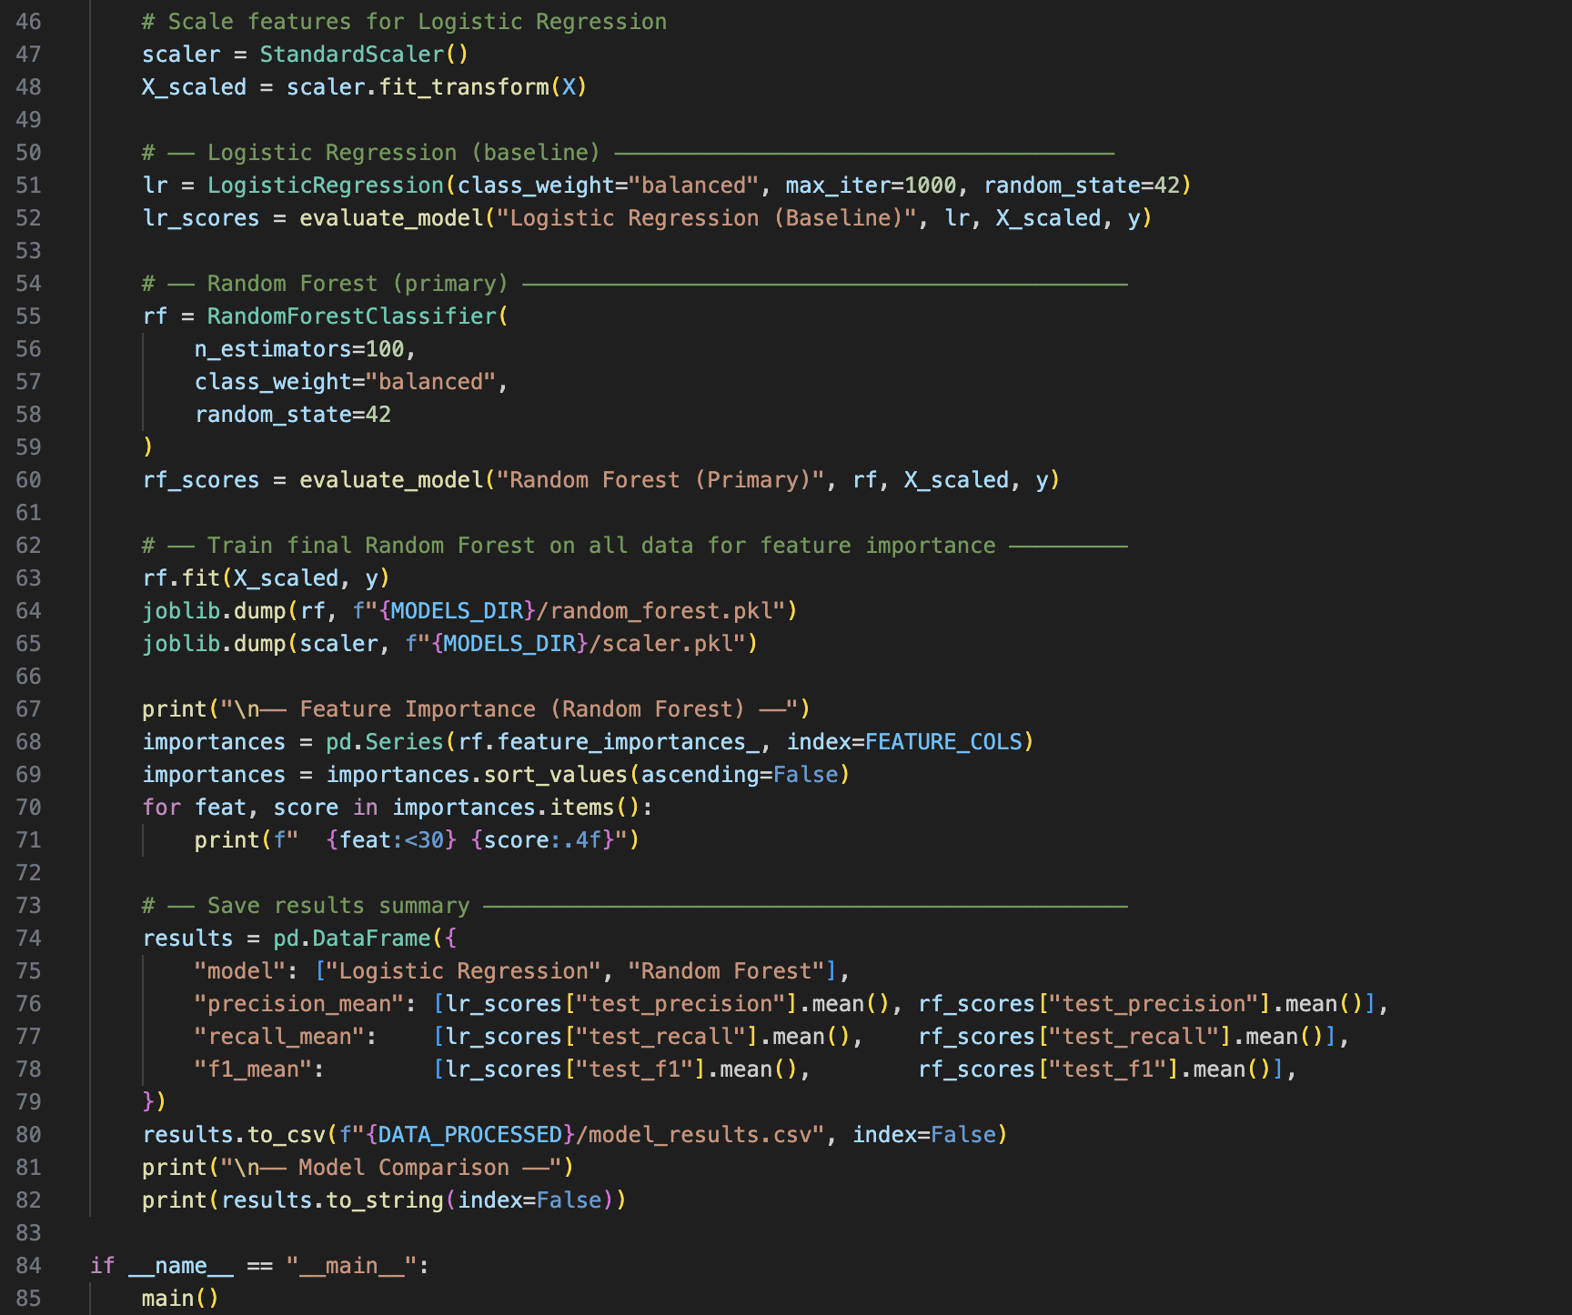
This is the current status of my end-to-end pipeline:
- Data Ingestion – complete
- Feature engineering – complete
- Label generation – Partially complete
- Supervised ML model – Pending training

My planned next steps are to expand my datasets with public Terraform and CloudFormation repositories that I have mentioned in previous reports, as well as to complete the rule-based baseline detection model. The issue that I previously mentioned regarding the null-field handling issue will also be researched and fixed next week.

